Excellent. We are now entering what I believe is the most important module in the entire application.
Modules 1–3 were about building the operational foundation.
Module 4 – Weekly Tracker is where placement operations are actually managed from start to finish.

Our Goal for Module 4
We are not going to design the screen first.
Instead, we'll understand exactly how your placement team works.
Once the workflow is crystal clear, the UI will almost design itself.

What I Need From You
I don't need you to think like a software developer.
I want you to think like a Placement Coordinator or Team Leader.
Imagine it's Monday morning.
A company has already given a positive response and now appears in the Weekly Tracker.
Now tell me, in your office, what happens next?

Question 1 – Entry into Weekly Tracker
How does a company enter the Weekly Tracker?
For example:
Daily Tracker

↓

Call Outcome = Invite Mail

↓

Submit Day

↓

Automatically appears in Weekly Tracker
Or is there another rule?

Question 2 – What is the Purpose?
In one sentence:
Why do we maintain the Weekly Tracker?
For example:
- To monitor all ongoing placement activities.
- To ensure no positive company is missed.
- To track every stage until placement is completed.
Tell me your team's actual purpose.

Question 3 – What Happens After It Appears?
Let's say Infosys appears in the Weekly Tracker.
What is the first thing the coordinator does?
Example:
Invite Sent

↓

Wait for JD

↓

Receive JD

↓

Share with TPO

↓

Schedule Drive

↓

Conduct Drive

↓

Collect Results

↓

Offer Released

↓

Completed
I want the real office workflow, not the software workflow.

Question 4 – Who Updates It?
Who is responsible for updating the Weekly Tracker?
- Placement Coordinator?
- Team Leader?
- Both?
Can both edit the same company?

Question 5 – When Does It End?
When do we remove a company from the Weekly Tracker?
When:
- Drive completed?
- Offers released?
- Company rejected?
- Hiring closed?

If You Have an Excel File
This would help even more.
If your company already maintains a Weekly Tracker in Excel, upload it.
Then we'll:
- Study the columns.
- Understand why each exists.
- Remove unnecessary fields.
- Add missing automation.
- Design a much better digital version.

My Plan for Module 4
We'll build it in the same structured way as the previous modules.
Stage 1 – Business Workflow
- Purpose
- Entry
- Exit
- Users
Stage 2 – Data Structure
- Columns
- Statuses
- Editable fields
- Auto-populated fields
Stage 3 – Business Rules
- Permissions
- Validation
- Automation
Stage 4 – UI Design
- Layout
- Toolbar
- Grid
- Filters
- Search
- Color coding
Stage 5 – Integration
- Daily Tracker
- Monthly Tracker
- Dashboard
- Reports
- Notifications

What You Need To Do Now
Just explain the Weekly Tracker exactly as your team uses it today.
Don't worry about software terms.
Tell me things like:
"After I send the invite, I wait for the JD. Once I receive the JD, I update the sheet. Then I coordinate with the college, schedule the drive, update the interview rounds, and finally mark the drive as completed."
That's enough. I'll convert your business process into a professional software workflow, just as we did for Modules 1–3. Once that workflow is finalized, we'll design a Weekly Tracker that fits your team's operations instead of forcing your team to adapt to the software.
prompt 1 - For the module 4 weekly tracker, which is a very most important thing that has a direct connection with the daily tracker we maintain and the weekly tracker. Daily tracker is, it is a starting point, weekly tracker is the ending point for a placement coordinator and the team leader also. Finally, admin is going to monitor everything whenever he needs. So here, I have attached the four screenshots how the weekly tracker is looking and how we monitor it with the column names and the sample is there. So here, we have companies completed, companies in progress, companies in pipeline, top companies, rejected companies by HR, rejected companies by TPO, I mean college. And then if you want, we can add a summary table or summary KPI cards. That's up to the design wish planning. So first question is, when we enter into the weekly tracker, the weekly tracker looks like a same Excel view, Excel view only, which is editable by, completely editable, deletable, updatable by the team leader and placement coordinator. So here we are going to have serial number, company name, role, CDC, company type, status. These are the columns that present. The purpose is, monitor all the ongoing placement activities and ensure both the past teams, the flow which we maintain after the invite email sent, whether the job description received, whether the student database is shared to the training and placement office side to HR side, whether the HR is discussing with the drive scheduling process, whether the drive was scheduled, and even we have to look towards the drive in progress activities like first round completed, second round completed, or particular round is going on like technical round, aptitude round, group discussion, HR round one. So all the rounds are completed, we are going to mention as drive completed. Or we can even tell awaiting results. So once the awaiting results status changes to drive completed, automatically the company is moved from companies in progress to completed companies. So at that time the status will be changed as drive completed and in completed companies we're having an extra column called offers. In the offers column we will mention how many students got placed in the company, the count of the students, either four, five, or ten, it can be anything. So this is the workflow how it works. So companies in pipelines are the companies which have not received the job description. So the companies which received job description will be moved to the companies in progress. Which have not received the job description, just the invitation email sent or invitation email is yet to send, those companies will stay in the companies in pipeline section. And top 10 companies are the companies which are most accurately sure that these will be converted into a job description and drive scheduling status. So it can be top 10, you can just mention top companies and inside it can be 10 companies. When the pipeline company exceeds more than 15 companies, at that time we have to randomly pick 10 companies based upon the software, techie roles with a high LPAs, reasonably more than 4 to 5 LPAs, and put it in the top companies. It is also manually editable, that's not a problem. We just going to copy the particular row and paste it in the top companies. And the rejected by college, rejected by HR will be filled manually by the recruiters, required by our team leaders or by the placement coordinators. So this is the actual purpose and workflow. And so suppose there is a company called Infosys, the invite email is sent, it will be in the pipeline section. Once I receive the JD through email, I will move it to the progress section. After that I will mention like remove the status from JD, awaiting JD, I will type it as student database yet to be shared at the earliest. Once the database is sent, I will erase it and I will type it as awaiting drive scheduling process from the TPO, HR side. And once the drive date is confirmed, I have to tell drive date is confirmed. The status is everything manually edit, so it doesn't matter about it. So once the JD received, it will be pushed to the companies in progress. That is a point. Once completed drive, it will push to the companies completed. And the person who are going to update this is completely both the placement coordinator and the team leader. So according to the question five, when does it end means when the status become drive completed and the offer box is filled. When you see the status in the table section, companies completed as drive completed, that particular company flow is completed. So it will be fixed, it's done, all done. And that's all so far we have planned for this weekly tracker. By daily the weekly tracker can be monitored, updated, reviewed, deleted even some rows or some editing options is available. So for the version one we are going to plan for this. If you have any doubts or queries regarding this, you can come up. The layout is definitely going to be with KPI cards, status states, and the main thing is the table, the Excel table, live Excel, like Google Sheets or SharePoint, OneDrive sheets like tables, you're going to have with rows and columns.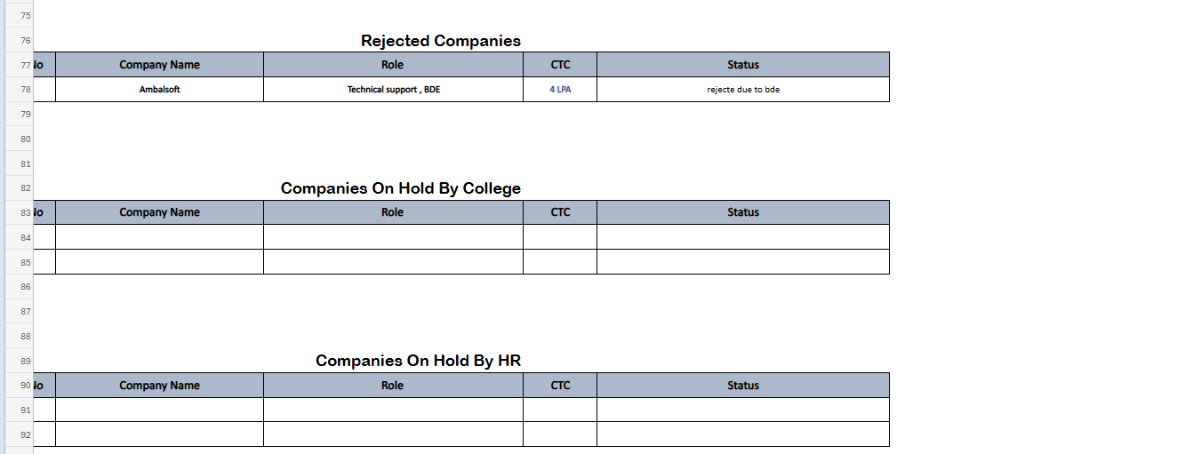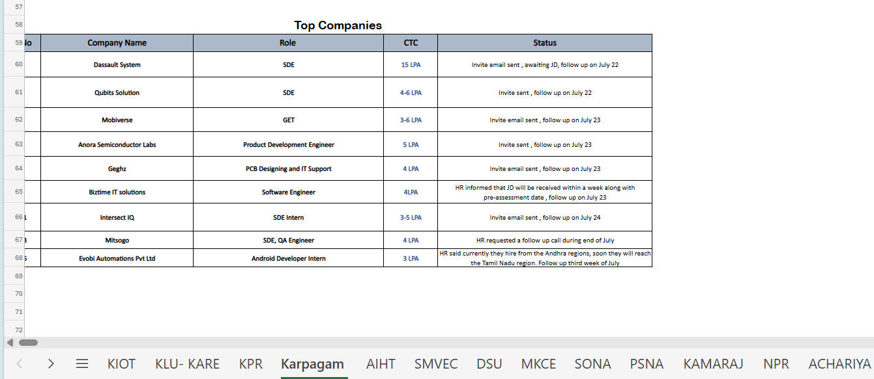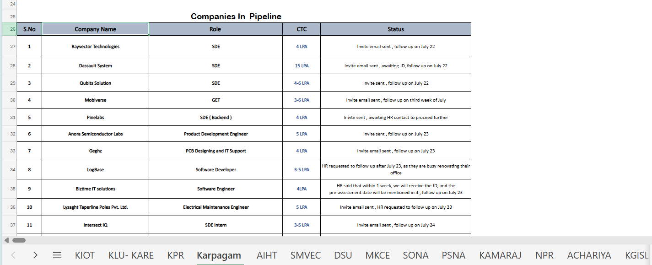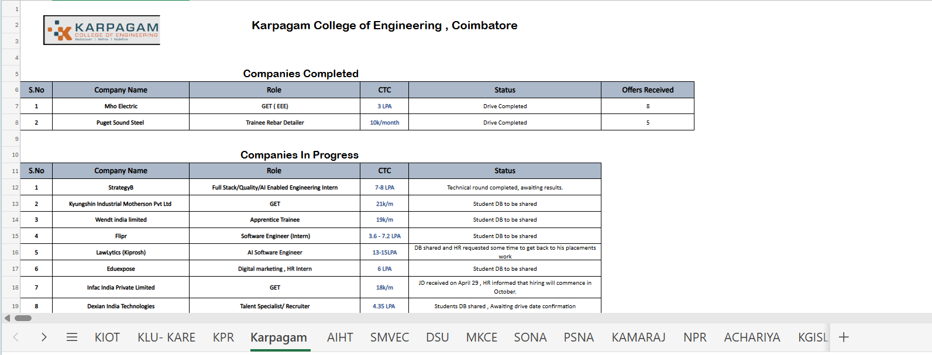

response 1 - This is exactly the kind of explanation I was looking for. More importantly, after seeing your screenshots and reading your workflow, I have one major observation.
I don't think the Weekly Tracker should be treated as six separate tables anymore.
The Excel version is divided into:
- Companies in Pipeline
- Companies in Progress
- Companies Completed
- Top Companies
- Rejected by HR
- Rejected by College
That structure works in Excel because there's no automation.
But in iPOMS, we can make it much smarter.

My Biggest Recommendation for Module 4
Instead of maintaining six different editable tables, maintain one master Weekly Tracker table.
Then the system automatically creates the different views.
Concept
Weekly Tracker Master Table
│
┌─────────────┬─────────────┬─────────────┐
│ │ │ │
Pipeline In Progress Completed Rejected
│ │ │ │
└─────────────┴─────────────┴─────────────┘
Top Companies
The coordinator edits only one record.
The software decides which section it belongs to.

Example
Suppose Infosys has:
Status:
Invite Email Sent
Automatically appears in
✅ Pipeline

Later,
Status becomes
JD Received
Automatically disappears from Pipeline.
Automatically appears in
✅ Companies in Progress

Later,
Status becomes
Drive Completed
Offers = 12
Automatically moves to
✅ Companies Completed

Nobody manually cuts and pastes rows anymore.

This Solves Many Problems
Currently in Excel:
Copy
↓
Paste
↓
Delete
↓
Rearrange
↓
Sort
↓
Mistakes happen.
In software:
Only update Status.
Everything else happens automatically.

Same for Rejected
Status
Rejected by HR
↓
Automatically goes to
Rejected Companies.

Status
Rejected by College
↓
Automatically goes there.

Top Companies
I also have an automation idea.
Instead of manually copying rows,
the system can recommend the Top Companies based on configurable rules.
For example:
- CTC ≥ 4 LPA
- Software / IT roles
- Status is Pipeline or In Progress
- Not rejected
It can automatically show the Top 10.
You can still provide a manual "Pin as Top Company" option to override the automatic list.

I Like One Thing About Your Workflow
You said:
Status is completely editable.
I completely agree.
I don't want the Weekly Tracker to force users into rigid dropdowns.
Instead,
Status should behave like a rich editable field.
Example:
JD received.
Waiting for TPO approval.

Drive scheduled for Aug 2.

Technical Round Completed.

Awaiting Results.
This is much more flexible.

I Think the Weekly Tracker Needs These Columns
Column | Type
S.No | Auto
Company Name | Auto
Role | Editable
CDC | Editable
Company Type | Auto
CTC | Editable
Current Stage | Dropdown
Status / Remarks | Rich Text
Last Updated | Auto
Updated By | Auto
Notice I separated:
Current Stage
and
Status / Remarks
because they serve different purposes.
For example:
Current Stage = Drive Scheduled
Status =
Drive confirmed for July 28.

Students informed.

Waiting for HR meeting.
This makes reporting much easier while still allowing detailed notes.

KPI Cards
I think these should be at the top.
Pipeline Companies

In Progress

Completed

Rejected

Top Companies

Offers Received

Average CTC

Upcoming Drives
Everything updates automatically.

My Questions Before We Finalize Module 4
I have five questions.
Question 1
Should every company have one row only in the master table?
Or can the same company appear twice if it has different roles?
For example:
Infosys – Software Engineer
Infosys – Data Analyst
Should those be:
One row or Two rows?

Question 2
If Infosys recruits for three roles,
what should happen?
Software Engineer

Data Analyst

QA Engineer
Three separate rows?
Or one company with multiple roles?

Question 3
Should every update create a history log?
For example:
July 21

Invite Sent

↓

July 22

JD Received

↓

July 24

Database Shared

↓

July 27

Drive Scheduled
This would allow users to see the complete journey of a company without losing previous information.

Question 4
Should the Status / Remarks field support long notes with timestamps, or should it always display only the latest status?

Question 5 (Most Important)
You mentioned:
"Everything is editable."
I agree.
But should Completed companies still be editable?
Or should we lock them after completion and require reopening the record if changes are needed?

My Opinion
I think Module 4 has the potential to become the strongest part of iPOMS.
The Daily Tracker captures what happened today.
The Weekly Tracker should tell the complete story of every company—from the first positive response until the drive is completed and offers are received.
If we design this well, coordinators won't need to maintain multiple Excel sheets anymore. They'll simply update one record, and the system will automatically organize it into Pipeline, In Progress, Completed, Top Companies, or Rejected. That will reduce manual work, eliminate duplication, and make the Weekly Tracker much easier to maintain while preserving the workflow your team already follows.
Prompt 2 - Have you seen the responses for each and every company I given for all the sections? The status column. Take a look. See the manual responses we type. That is how we type the manual response for everything. Sometimes in Pipelne also we never come to know whether the invite is sent or not. We have just simply said HR requested to follow up after a month, and the date is given. So, you can also add a column like date when to follow up. Status in mention, HR asked for follow up. In the date column we can pick the date when we are going to make a follow up.I think it's better to give the option to edit, select the row, deselect the row, rearranging also, because according to the recent follow-up date, it needs to be arranged. For example, there are 10 companies in pipeline. First company is September 1, second company is August 15. Then obviously, they need to be arranged, promising on a date-wise. And also, we are going to have an option filter like sort based on date, based on LPA. We are going to do that. And it's applicable for all the sessions. If we are not going to have such kind of table means, how the weekly report is going to look? Because we are having completed section, pipeline section, in progress, top companies, rejected by HR, rejected by TPO. So here, you are having an automation idea for top companies, right? Manually copying the row, you are telling the system can recommend the top companies based on configuration rules, which I told that the CTC should be greater than or equal to 3 LPA. Let's fix with that, 3 LPA. That is more reasonable. Or even 4 LPAs also good. And the roles need to be techie roles, software engineer, design engineer, developer, if first check the LPA. If the LPA is more and the role is also techie, AI engineer, data scientist, production engineer, you can directly try to keep them in top companies. Also, I want one of the future, like the company whatever we enter, is there any possibility that I can come to know about the worth of company? Not in this version, even in future versions also we can try that. So I need to know about the reviews of the company from the top reviewing websites in the browsers. But I want a manual way to pin top companies in the top companies section. Also, what else can be improved in this? You just give me some ideas if you have anything. Definitely serial number is automatic, company name is also automatic from the data tracker connection, but we are having the editable option for all the columns. That is mandatory. All the placement coordinator and team leaders are having the full editing option for all the columns. So you have noticed something. Why current stage and status or remarks? You are telling both are different purpose. Current stage means drive scheduled, status and remark means confirm before June 28th, students informed. No, no, no. We can have only one column, just a status is enough. We are going to type everything, and we are having a date column where we are mentioning the date when we need to follow up, when we need to remind the HR. No need to confuse the dashboard. So KPIs are good. So the questions before we finalize the model 4 is for the question 1, should every company have one row only in the master table? Or the same company appear twice, it has different roles. Multiple roles are given in the role section, not only one role. If I have multiple roles, I can able to type multiple roles in that particular cell. For example, in firsts can have both the software engineer, comma data analyst, comma full stack developer, comma AI engineer. You can have anything. So according to question 2, if in fors like 3 roles, yes, all the three need to be in the same row in the same cell, separated by comma. Should every update create a history log? No need history log for now. In future if we want, we can append that. We are going to have only column called status that's going to support the commas in a free text format, and we are going to have a follow-up date column where the date is picked to make a follow-up. Question 5, everything is editable. Yes, this is the most important thing.
Reponse 2 - Yes, I carefully looked at every status you typed in the screenshots. That actually changed my understanding of the Weekly Tracker.
Initially, I was thinking like a software designer, trying to normalize the data. But after reading your actual entries, I think your team's way of working is correct, and the software should adapt to it—not the other way around.
For example, I noticed statuses like:
- Invite email sent, awaiting JD, follow up on July 22
- HR requested a follow up call during end of July
- HR said currently they hire from Andhra regions, soon they will reach Tamil Nadu region. Follow up third week of July
- Student DB to be shared
- JD received on April 29, HR informed that hiring will commence in October
- Technical round completed, awaiting results
These are not just "statuses." They are live operational notes. If we force them into predefined stages, we'll lose valuable context.
So I completely agree with keeping one free-text Status column.

I Think We Should Slightly Improve the Table
Instead of:
| Company | Role | CTC | Status |
I recommend:
| S.No | Company | Role | CDC | Company Type | CTC | Follow-up Date | Status |
This is only one extra column, but it gives a huge benefit.
For example:
Company | Follow-up Date | Status
Infosys | 22-Jul-2026 | Invite email sent, awaiting JD
Zoho | 30-Jul-2026 | HR requested follow-up after one month
TCS | 25-Jul-2026 | Student DB to be shared
Now the coordinator can simply sort by Follow-up Date every morning and immediately know whom to contact.
I think this is one of the biggest productivity improvements we can make.

About the Multiple Sections
Earlier I suggested a single master table.
Now I think we can combine both ideas.
Internally, the application will maintain one master dataset.
Visually, the user will still see the familiar sections:
- Companies in Pipeline
- Companies in Progress
- Companies Completed
- Top Companies
- Rejected by HR
- Rejected by College
This gives the user the same experience they're already comfortable with, while the system keeps the data organized underneath.

Top Companies
I think we should support both Automatic and Manual.
Automatic
Suggest companies where:
- CTC ≥ 4 LPA (or 3 LPA if you finalize that)
- Technical role
- Not rejected
- Pipeline or In Progress
Manual
Every row should have a ⭐ Pin to Top Companies action.
If you pin it, it always appears in the Top Companies section regardless of the automatic rules.
This gives the best of both worlds.

Future Feature: Company Insights
I really liked your idea.
Imagine clicking on Infosys.
A side panel opens showing:
- Company website
- Industry
- Employee count
- Headquarters
- Company description
- Glassdoor rating
- AmbitionBox rating
- Hiring trends
- Recent news
- Previous placement history within iPOMS
That would be an excellent Version 2 feature. It would help coordinators understand the company before making follow-up calls.

One Feature I'd Like to Add
Based on your workflow, I think we're missing one small but powerful feature.
Follow-up Indicator
Every row could have a small colored indicator based on the Follow-up Date.
For example:
🟢 More than 7 days away
🟡 Within the next 3 days
🔴 Follow-up due today or overdue
Without opening the status, the coordinator immediately knows which companies need attention.

Another Improvement
At the top of the Weekly Tracker, instead of only KPI cards, we could also show:
- 📌 Follow-ups Due Today
- 📅 Follow-ups This Week
- 📈 Active Pipeline
- 🎯 Top Companies
- ✅ Completed Drives
- ❌ Rejected Companies
These cards become actionable. Clicking one filters the corresponding table automatically.

Module 4 Status
I think we're now around 70–75% complete with the business design.
We've finalized:
- ✅ Purpose
- ✅ Workflow
- ✅ Editable behavior
- ✅ Pipeline logic
- ✅ Progress logic
- ✅ Completion logic
- ✅ Rejected sections
- ✅ Top Companies
- ✅ Free-text Status
- ✅ Follow-up Date
- ✅ Sorting and filtering
- ✅ Multiple roles in one cell
- ✅ Full editing permissions

The Remaining Things We Need to Finalize
I think only four topics remain before Module 4 is complete:
- Exact toolbar actions (Add, Delete, Move, Pin, Export, etc.).
- KPI cards and summary calculations (what each card should display and how it's calculated).
- UI layout (how the five sections are arranged on the screen while remaining clean and responsive).
- Automation rules (exactly which records move automatically between Pipeline, Progress, Completed, and Rejected).
Once we finalize those four areas, I believe Module 4 will be as complete and well-defined as Modules 1–3. Then we'll have a solid operational backbone for iPOMS before moving on to the Monthly Tracker.
Prompt 3 - how thw weekly repot will be visuallized ?

Response 3 - This is where I think we should improve significantly over Excel.
The current Excel weekly report is functional, but it doesn't help you prioritize work. You have to scrol
l through multiple sections to understand what needs attention.
My recommendation is to visualize the Weekly Tracker as a single dashboard page with multiple sections.

Weekly Tracker Layout (iPOMS)
┌──────────────────────────────────────────────────────────────────────┐
│ Weekly Tracker Week: 21 Jul - 27 Jul │
├──────────────────────────────────────────────────────────────────────┤
│ KPI Cards │
│ Pipeline | Progress | Completed | Rejected | Follow-ups | Top Co. │
├──────────────────────────────────────────────────────────────────────┤
│ 🔔 Follow-ups Due Today │
│ Company | Role | Follow-up Date | Status │
├──────────────────────────────────────────────────────────────────────┤
│ ⭐ Top Companies │
│ Company | Role | CTC | Status │
├──────────────────────────────────────────────────────────────────────┤
│ 📋 Companies in Pipeline │
│ Excel-like editable table │
├──────────────────────────────────────────────────────────────────────┤
│ ⚙ Companies in Progress │
│ Excel-like editable table │
├──────────────────────────────────────────────────────────────────────┤
│ ✅ Companies Completed │
│ Excel-like editable table + Offers │
├──────────────────────────────────────────────────────────────────────┤
│ ❌ Rejected Companies │
│ HR Rejected | College Rejected │
└──────────────────────────────────────────────────────────────────────┘

KPI Cards
At the top, I recommend six cards.
KPI | Example
📌 Pipeline | 18
⚙ In Progress | 9
✅ Completed | 15
❌ Rejected | 4
📅 Follow-ups Due Today | 6
⭐ Top Companies | 10
Clicking a card filters the relevant table.

Section 1 – Follow-ups Due Today (New)
This is something your Excel doesn't have, but I think it will become the most-used section.
Company | Follow-up Date | Status
Infosys | Today | HR requested follow-up
Zoho | Today | Awaiting JD
TCS | Today | HR asked to call after 2 PM
When coordinators log in, they immediately know who to contact first.

Section 2 – Top Companies
Only the most promising companies.
Company | Role | CTC | Status
Infosys | SDE | 12 LPA | Awaiting JD
Zoho | Developer | 8 LPA | Drive Discussion
Freshworks | AI Engineer | 10 LPA | Database Shared
This stays compact—around 10 rows.

Section 3 – Companies in Pipeline
This is the largest editable table.
S.No | Company | Role | CDC | Type | CTC | Follow-up Date | Status
Everything is editable.
Sorting:
- Follow-up Date
- CTC
- Company
- Role
Filtering:
- College
- Company Type
- Date
- Coordinator

Section 4 – Companies in Progress
Same table structure.
Difference:
The status will contain entries like:
- Student DB Shared
- Awaiting Drive Schedule
- Technical Round Completed
- HR Round Ongoing
- Awaiting Results

Section 5 – Companies Completed
Same layout, with one extra column.
Company | Role | CTC | Offers | Status
Offers becomes editable only in this section.

Section 6 – Rejected Companies
Instead of two separate tables, I suggest one table with a reason.
Company | Role | CTC | Rejected By | Status
ABC | SDE | 4 LPA | HR | Hiring Closed
XYZ | GET | 5 LPA | College | Eligibility Criteria
You can still filter by "Rejected By = HR" or "College."

Toolbar
The Weekly Tracker toolbar could include:
+ Add Company Refresh Save

Search

Filter

Sort

Export Excel

Print

Pin Top Company

My Biggest Suggestion
I would also add a Week Selector.
Week:

◀ Previous Week

21 Jul – 27 Jul

Next Week ▶
This allows coordinators and team leaders to review previous weeks without leaving the module.

Why This Design is Better Than Excel
The Excel sheet forces users to scroll between different sections and manually identify priorities.
The iPOMS Weekly Tracker would instead guide the user:
- First: Check Follow-ups Due Today.
- Second: Review Top Companies.
- Third: Update Pipeline.
- Fourth: Update In Progress.
- Finally: Close Completed and Rejected companies.
It follows the actual order of work rather than just storing information.

One Enhancement I'd Like to Add
I think every company row should have a Quick Action button (⋮) on the right.
When clicked, it could show actions like:
- ✏ Edit
- ⭐ Pin to Top Companies
- 📋 Copy Row
- 📅 Change Follow-up Date
- 📤 Move to Progress
- ✅ Move to Completed
- ❌ Mark as Rejected
This gives coordinators fast access to common actions without cluttering the table, while still keeping the familiar Excel-like editing experience you've emphasized throughout the project. I think this strikes a good balance between spreadsheet flexibility and modern application usability.
Prompt 4- So I want you to arrange the companies in the order like you have to arrange, follow-up due today. If for the first day it won't be available, from the second day we can come to know follow-up due today is necessary or not. And then you have to show companies in progress. And then you have to show companies in pipeline. And then you have to show companies completed. After that, rejected companies by HR, rejected companies by college. So before companies completed, you have to mention top companies. So this is how the order need to be maintained. Yeah, you can even use a weekly selector to look up for the previous week and this week. The week range can be even monitored from the day we begin. That is, daily weekly report will be updated by us. And when the team leader says to update weekly report, that time also we have to update the weekly report. So from the daily tracker, automatically the companies will be shown in the weekly tracker. But if you want to add any new companies manually means we need some add button, right? So before the serial number, if possible, we can click, use a plus icon to add any particular row by manually. Or normally if a user can add a row in the weekly report of any of the sections, what we can do. And obviously this enhancement, the quick action button is good.
Response 4 - I think we're getting very close to finalizing Module 4. Looking at your explanation, I would refine the Weekly Tracker into something like this.

Module 4 – Weekly Tracker (Layout Version 1)
┌─────────────────────────────────────────────────────────────────────────────┐
│ Weekly Tracker Week: 21 Jul - 27 Jul │
├─────────────────────────────────────────────────────────────────────────────┤
│ KPI Cards │
│ Pipeline | Progress | Completed | Rejected | Due Today | Top Companies │
├─────────────────────────────────────────────────────────────────────────────┤

🔔 Follow-up Due Today
───────────────────────────────────────────────────────────────────────────────
Editable Excel Table

⚙ Companies In Progress
───────────────────────────────────────────────────────────────────────────────
Editable Excel Table

⭐ Top Companies
───────────────────────────────────────────────────────────────────────────────
Editable Excel Table

📋 Companies In Pipeline
───────────────────────────────────────────────────────────────────────────────
Editable Excel Table

✅ Companies Completed
───────────────────────────────────────────────────────────────────────────────
Editable Excel Table

❌ Rejected By HR
───────────────────────────────────────────────────────────────────────────────
Editable Excel Table

❌ Rejected By College
───────────────────────────────────────────────────────────────────────────────
Editable Excel Table
I actually think this order is much better because it matches the coordinator's daily work:
- Check follow-ups.
- Continue active companies.
- Watch the most promising companies.
- Handle new pipeline companies.
- Review completed drives.
- Review rejected companies.
That is exactly how a placement coordinator thinks.

About Adding New Rows
This is a very good point.
The Weekly Tracker should not depend only on the Daily Tracker.
Sometimes the Team Leader may receive information through:
- LinkedIn
- HR WhatsApp
- Personal Contact
- College Management
- Previous Email Conversation
So they should be able to manually add a company.
I recommend two ways.
Method 1 (Recommended)
Toolbar
+ Add Company
Clicking it opens a popup.
The popup asks:
- Company Name
- Role
- CDC
- Company Type
- CTC
- Follow-up Date
- Status
After clicking Save,
the company automatically goes into Pipeline.

Method 2
Exactly as you suggested.
Inside every table
+
above the first row.
Clicking it inserts a blank editable row.
Example
+ Add New Row

1

2

3
This feels like Excel.

My Recommendation
Let's combine both.
Toolbar
+ Add Company
For complete company creation.
Inside Every Table
+
Insert New Row.
This allows quick editing.

One More Improvement
Instead of only
+
I recommend
+

Duplicate

Delete

Move
on every row.
Example
⋮

Edit

Duplicate

Move

Delete

Pin Top Company
Very similar to Google Sheets.

Another Automation
Suppose a coordinator manually creates
Infosys

Status

JD Received

Instead of asking
"Where should I add it?"
The software automatically decides.
If
Status contains
JD Received
↓
Companies In Progress
If
Status contains
Drive Completed
↓
Completed
If
Status contains
Rejected
↓
Rejected
Otherwise
↓
Pipeline
The user doesn't have to think about the destination.

I Have One More Idea
Since this is an Excel-style system,
what if every table has
+ Add Row

Ctrl + Enter
to instantly insert a new row?
Your coordinators already work heavily with keyboards, so supporting keyboard shortcuts here would make the Weekly Tracker even faster to use.

My Opinion on Module 4
I think this module is gradually becoming the heart of iPOMS.
- Daily Tracker answers: "What calls did we make today?"
- Weekly Tracker answers: "Where does every company stand in the placement journey?"
It becomes the single operational board that coordinators, team leaders, and administrators rely on every day.

One Suggestion Before We Continue
I think we should make one small terminology change.
Instead of calling this "Weekly Tracker", consider calling it "Placement Pipeline" inside the application, while still referring to it as the Weekly Tracker in your internal process if your team is used to that name.
The reason is that the data isn't really tied to a calendar week. A company can remain in the pipeline for several weeks until the process is complete. Calling it a "Placement Pipeline" better reflects its purpose.
However, if your team has been using the term Weekly Tracker for a long time and everyone immediately understands it, I would keep that name. User familiarity is more valuable than changing terminology just because it sounds more technical.
Prompt 5 - I will tell the order again. Follow-up due today, companies completed, companies in progress, companies in pipeline, top companies, companies rejected by HR, companies rejected by college. This is the order, maintain this.So for adding a new company, let's go with the combination of both ways. So a toolbar and inside of the table, we can add a quick
three dots, which is going to show edit, duplicate, move, delete, pin top company.Suppose anybody is manually creating any particular row, you have to ask the sections from the user itself, whether I need to add pipeline, in progress, completed, rejected by HR, rejected by TPO, top companies. You have to ask the option. When I say the, when I select the particular section, in that section, at the last, it need to be stored. Once it is stored, according to the follow-up date, it need to be sorted again, ascending order.So finally, we have to decide how the user is going to add in between if they want any data to be inserted in any row, whether it is plus sign or how they are going to add. There should not be so congested designs. There should not be so much of confusions in designing also. It need to be very easy, smooth, and clean way of understanding.Once these discussions are done, I hope the module four for weekly report is also completed.

Response 5 - I think we've reached the point where Module 4 is functionally complete. The remaining work is only documenting it professionally. I agree with your final decisions, and I'd like to make one small UI refinement to keep the interface clean.

Module 4 – Weekly Tracker (Final Layout)
Header
- Weekly Tracker
- Week Selector (Previous / Current / Next Week)
- Search
- Filter
- Sort
- Export
- Refresh
- + Add Company

KPI Cards
- 📅 Follow-ups Due Today
- ⚙ Companies In Progress
- 📋 Companies In Pipeline
- ⭐ Top Companies
- ✅ Companies Completed
- ❌ Rejected Companies

Sections (Final Order)
- 🔔 Follow-up Due Today
- ✅ Companies Completed
- ⚙ Companies In Progress
- 📋 Companies In Pipeline
- ⭐ Top Companies
- ❌ Rejected by HR
- ❌ Rejected by College
This order will be maintained throughout the application.

Adding a New Company (Final)
We will support both methods.
Method 1 – Toolbar
+ Add Company
Opens a popup.
Fields:
- Company Name
- Role
- CDC
- Company Type
- CTC
- Follow-up Date
- Status
New Field
Section
Dropdown:
- Pipeline
- In Progress
- Completed
- Top Companies
- Rejected by HR
- Rejected by College
When Save is clicked:
- The record is added to the selected section.
- The table immediately re-sorts based on the Follow-up Date (ascending).

Method 2 – Quick Insert Row
This is where I want to make a slight improvement.
Initially, we discussed having a "+" button inside every table.
I think a permanent "+" on every row might make the interface feel busy.
Instead, I recommend a cleaner interaction.
When the user right-clicks or uses the ⋮ Quick Action menu, they see:
Insert Row Above

Insert Row Below

Duplicate Row

Delete Row

Move Row

Pin to Top Companies
This feels much more like Excel while keeping the screen uncluttered.
If you still want a visible button, we can place one small "+" button in the table header, not on every row.
That keeps the layout clean.

Quick Actions (Final)
Every row has:
⋮
Options:
- ✏ Edit
- 📄 Duplicate
- ⬆ Move
- 🗑 Delete
- ⭐ Pin to Top Companies
Simple and consistent.

Sorting
Every section automatically sorts by:
- Follow-up Date (ascending)
- Company Name (if dates are equal)
Users can still manually sort by:
- CTC
- Company Name
- Role
- CDC
- Company Type

Editable Fields
Everything is editable.
- Company Name
- Role
- CDC
- Company Type
- CTC
- Follow-up Date
- Status
This matches your team's current workflow.

One Improvement I'd Like to Add
This is something I think your team will appreciate after using the system for a few weeks.
Sticky Section Headers
As the user scrolls down the Weekly Tracker, the current section header remains visible.
For example:
Companies In Progress
--------------------------------

...

...

...

(scroll)

Companies In Progress
(sticky at top)

...

...

This helps users stay oriented, especially when there are many rows.

Module 4 Completion Status
I would now mark Module 4 as:
Module 4 – Weekly Tracker
Status: ✅ Business Design Completed (Version 1.0)

Overall Project Status
Module | Status
Module 1 – User Management | ✅ Completed
Module 2 – Master Company Database | ✅ Completed
Module 3 – Daily Tracker | ✅ Completed
Module 4 – Weekly Tracker | ✅ Completed

One Final Suggestion
I noticed something while designing Modules 1–4.
Each module follows a clear lifecycle:
- Module 2 creates the master data (companies and contacts).
- Module 3 records daily communication.
- Module 4 manages the placement pipeline until completion.
This means Module 5 (Monthly Tracker) doesn't need to reinvent any workflow. It should focus on consolidation and performance monitoring—bringing together the outcomes of the Daily and Weekly Trackers into monthly summaries, trends, and achievements. That separation of responsibilities will keep each module focused, easier to use, and easier to maintain as iPOMS grows.
Prompt 6 - The week selector is going to work like not calculating seven days. It's going to calculate from one Friday to next Friday. It depends upon Friday calculation.No need of the small plus button. Rather than the quick action menu is enough. So, the sticky section header is accepted. When the user scrolled on the Wiki tracker, the current section header remains visible definitely.

Response 6 - Perfect. Those are the last refinements I needed. I agree with both decisions.
1. Week Selector (Final)
This is an important business rule, and it's different from a normal calendar week.
The Week Selector will not use a rolling 7-day calculation.
Instead, it will follow your organization's reporting cycle.
Example:
Week 1
Friday (Start)
│
▼
Next Friday (End)

Week 2
Friday (Start)
│
▼
Next Friday (End)
So the selector will display something like:
◀ Previous Week

18 Jul 2026 – 24 Jul 2026

Next Week ▶
or
Week 30
18 Jul 2026 – 24 Jul 2026
This matches how your team actually reviews and submits the Weekly Tracker.

2. Adding New Rows (Final)
I completely agree.
Let's remove the visible "+" button entirely.
The final design will be:
Toolbar
- ➕ Add Company
Quick Action Menu (⋮)
- Edit
- Insert Row Above
- Insert Row Below
- Duplicate
- Move
- Delete
- Pin to Top Companies
This keeps the UI clean and avoids unnecessary buttons.

3. Sticky Section Headers (Final)
Accepted.
Each section header will remain visible while scrolling within that section.
Example:
────────────────────────────
⚙ Companies In Progress
────────────────────────────

...

...

(scroll)

────────────────────────────
⚙ Companies In Progress
────────────────────────────
This is especially useful because some sections may eventually contain dozens of companies.

I Have One Last Recommendation for Module 4
Since this module is essentially a live operational board, I suggest adding a small summary line below each section title.
For example:
Companies in Progress
⚙ Companies In Progress

9 Companies • Last Updated: 10:42 AM
Companies Completed
✅ Companies Completed

15 Companies • Total Offers: 84
Companies in Pipeline
📋 Companies In Pipeline

18 Companies • 6 Follow-ups Due This Week
Top Companies
⭐ Top Companies

10 Companies • Avg CTC: 7.2 LPA
This gives coordinators useful context without opening reports or counting rows.

Module 4 Status
I can now officially mark:
Module 4 – Weekly Tracker
Status: ✅ Completed (Business Design Version 1.0)

Overall Project Progress
Module | Status
Module 1 – User Management | ✅ Completed
Module 2 – Master Company Database | ✅ Completed
Module 3 – Daily Tracker | ✅ Completed
Module 4 – Weekly Tracker | ✅ Completed
Global Design Foundation | ✅ Completed
We now have the complete operational workflow defined:
Master Company Database
↓
Daily Tracker
↓
Weekly Tracker
This is a significant milestone because the operational backbone of iPOMS is now established. The remaining modules will primarily build on this foundation rather than redefining it. The next logical step will be Module 5 (Monthly Tracker), which will consolidate the outcomes of the Daily and Weekly Trackers into management summaries and performance insights.

